35.41: a) Hearing minimum intensity sound means that the path lengths from the individual speakers to you differ by a half-cycle, and are hence out of phase by 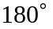 at that position.
b) By moving the speakers toward you by 0.398 m, a maximum is heard, which means that you moved the speakers one-half wavelength from the min and the signals are back in phase. Therefore the wavelength of the signals is 0.796 m, and the frequency is 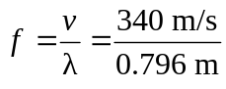=427 Hz.
c) To reach the next maximum, one must move an additional distance of one wavelength, a distance of 0.796 m.

